## [Infosys Practice Problems On Pins & Dimensions](http://www.careersvalley.com/infosys-practice-problems-pins-dimensions" \o "Infosys Practice Problems On Pins & Dimensions)

**Question 1** M/S. GRT Grand Hotels, Salem built their hotel recently. They wanted to decorate the Enquiry counter in a grand manner. They used square plates for this purpose. The square board is of size 41” x 41”. The carpenter in charge of decoration uses nails all along the edges of the square such that there are 42 nails on each side of the square. Each nail is at the same distance from the neighbouring nails. How many nails does the carpenter use for each square decoration board?

a) 124 b)164 c)204 d)168

**Answer :** b) 164

Solution :

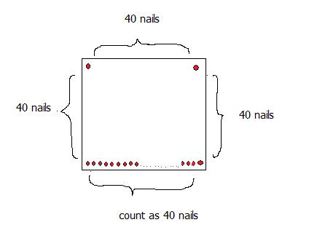  
To start with one nail can be fitted on each of the corners.  
Between two nails on any edge 40 nails have to be fitted so that the count becomes 42 when counted on any edge.  
Therefore total nails = 4 edge nails + 4 x 40 nails in between corners = 4 + 160 = 164  
(Note. though this is a simple question, you could be mislead to work out wrongly 42 x 4 = 168.)

**Question 2** Ms. Ganesh Mahal, Coimbatore wanted to present each of its customers with a momento rectangle in size. The momentos were of size 25 x 20 cm. The company requested the carpenter to make it in such a way that both 25 cm sides should have 24 nails each and the shorter sides should have 10 nails each. How many decorative nails the carpenter would have used in each momento?

a) 56 b)64 c)68 d)60

**Answer :** b) 64

Solution :

To begin with there should be one nail in each of the corners.  
There should be 22 nails on each of the two longer sides so that the count comes to 24 nails on each of those sides.  
There should be 8 nails on each of the shorter sides so that the count becomes 10 nails on each of the shorter sides.  
Total nails = 4 corner nails + 2 x 22 nails (longer sides) + 2 x 8 (shorter sides) = 4 + 44 + 16 = 64 nails.

**Question 3** Ramnath and Company was celebrating Silver Jubilee celebrations and the authorities wanted to present a Square cardboard momento fitted with decorative pins on all the four sides. They fitted 36 decorative pins with 1 cm distance between any two pins and with equal number of pins when counted on any side. Find the dimension of the cardboard.

a) 9 cm X 9 cm b) 10 cm X 10 cm c) 12 cm X 12 cm d) None of these

**Answer :** a) 9 cm X 9 cm

Solution :

To find the dimension, we have to find the number of pins on each of the sides of the square cardboard.  
Similar to solutions of previous questions, there will be 4 corner pins. Corner pins when added with pins on edges should amount to 36 as given. Let the number of pins in between the corner pins on each of the edges be x.  
Total Pins = 4 corner pins + 4 x number of pins on each of the edges in between corner pins  
36 = 4 + 4x  
32 = 4x or 8 = x  
Therefore number of pins on any of the edge = 2 corner pins + 8 pins in between the corner pins = 10 pins.  
Distance between each of the pins is 1 cm. Therefore the length of each of the sides = 9cm. Dimension of the square = 9 cm X 9 cm